AB 617 Community Air Protection Program
Annual Progress Reports for Community Emissions Reduction Programs
DRAFT Data Collection Template
DUE OCTOBER 1
Air District: | San Joaquin Valley APCD
Community Name: | Shafter

Reporting Requirement: Assembly Bill (AB) 617 requires that air districts prepare an annual report for each community emissions reduction program.
Data Collection: This template is designed to collect the information that is needed to create the required annual reports and is not intended to act as a substitute for the annual reports. After the data are collected, it is expected that air districts will work with their community steering committees to compile the information into their own user-friendly format(s) that reflects community concerns and summarizes progress, challenges, and next steps. California Air Resources Board (CARB) staff will compile data statewide to provide an overall update to CARB’s Governing Board and the public.
This data collection template includes: the metrics defined in each community emissions reduction program; action items from CARB Governing Board Resolutions and Staff Reports; and the minimum requirements listed in CARB’s Community Air Protection Blueprint. CARB staff will provide the relevant information on CARB strategies and associated emissions reduction progress for the annual reports. To support transparency, all information will be publicly available.
Due Date for Public Release: CARB’s Community Air Protection Blueprint states that annual progress reports must be made available to the public no later than October 1 of each year. Air districts must post the reports on their webpage, issue a public notification that the report has been released, and then present the report to the district board at a public hearing to discuss the contents.
Please provide the following information for your OVERALL community emissions reduction program
- Section A: Qualitative progress assessment and status updates for interim milestones identified by the CARB Governing Board; and Quantitative summary of progress
Please fill in the attached spreadsheet to provide an update on each strategy in your community emissions reduction program
- Section B: Status update for each strategy (attach spreadsheet)

Section A: QUALITATIVE progress assessment and status updates for interim milestones identified by the CARB Governing Board
- Provide a qualitative progress assessment. Briefly describe the progress made and provide a status update for each of the following items:
[Ref. Blueprint, page C-39, C-40]
- Community Engagement.
To ensure successful implementation of AB 617, residents, businesses, non-profits, agencies, and other stakeholders within Shafter have been fully engaged in both English and Spanish. The District has ensured that the CSC meetings continue to facilitate inclusive and balanced public engagement by providing:
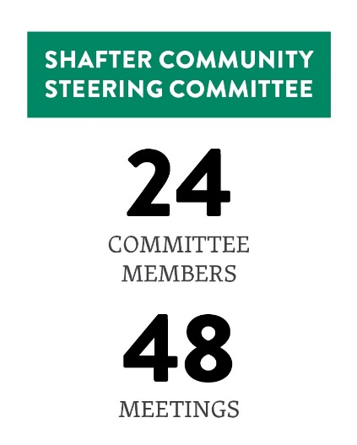
- Monthly evening meetings via Zoom, with technical assistance provided to residents and stakeholders upon request
- Continued real-time interpretation services through two Spanish interpreters at each meeting
- Meeting materials posted ahead of meeting, and send in hardcopy for Spanish-only speakers to facilitate more productive virtual meeting environments
- Monthly agenda-setting meetings with District, stakeholders, community co-hosts, CARB, and a third-party facilitator to collectively set expectations and plan for upcoming CSC meetings
- Expert presentations from partner agencies such as CARB, California Department of Pesticide Regulation (DPR), California Public Utilities Commission (CPUC), and Office of Environmental Health Hazard Assessment (OEHHA)
- A comprehensive and dedicated bilingual webpage with tools to view real-time air quality monitoring data and maps of emissions
- Neutral meeting facilitation by a community-recommended facilitation team to ensure meetings are inclusive and neutral by bringing out different points of view and preventing individuals from monopolizing discussions
- Weekly phone calls and text exchanges with our Spanish speaking CSC members to ensure they are engaged in the process

Ensuring effective steering committees as described above requires substantial investment of staffing and other resources to schedule, organize, and facilitate frequent after-hours public meetings with extensive related investigation and communications. The District has also continued to conduct public workshops throughout the Valley as needed to solicit additional community input while using outreach and media events as opportunities to discuss AB617 and promote the various grant programs available. Additionally, District staff provides updates and seeks feedback from the Citizens Advisory Committee (CAC) and Environmental Justice Advisory Group (EJAG) as the implementation of AB 617 in the Valley continues to develop.

Involving the public in the CERP implementation process continues to be a priority of the CSC and the District. All CSC meetings are promoted on social media and live streamed on Facebook with the meeting videos archived on the Shafter community webpage: http://community.valleyair.org/selected-communities/shafter/.

- Enforcement.
During the development of the Shafter CERP, CSC members identified several primary sources of concern within the community. Based on the analysis of the District’s enforcement history within the AB 617 community, several focused enforcement and compliance assistance measures were included in the CERP aimed at enhancing enforcement and education efforts through existing District enforcement programs to address those areas of community concern discussed below. In addition to the implementation of the enforcement measures adopted in the CERP, the District’s Compliance Department has continued over the past year to promptly respond to public air pollution complaints in the community. A complete summary of complaints received and enforcement actions taken over the past year is attached to this report.

Enhanced Enforcement of Wood Burning Curtailments
To limit the potential for localized PM2.5 impacts associated with the failure to comply with mandatory episodic wood burning curtailments under District Rule 4901, the District optimizes rule effectiveness to reduce the public health impact of wood smoke, the District dedicates extensive staffing resources to operate a robust Rule 4901 enforcement program covering all aspects of the rule. The District’s strategy focuses on both compliance assistance and enforcement activities. On all curtailment days, the District dedicates significant staffing resources to conducting surveillance in neighborhoods and responding to complaints from members of the public to ensure compliance with the rule. The District places fireplace surveillance and complaint response as the highest priority enforcement activity.

To address the community concern of residential wood burning, the District conducted enhanced residential wood burning surveillance within the AB 617 community on each "No Burning Unless Registered" and "No Burning for All" day declared (4 hours of surveillance per day) during the 2021-2022 wood-burning curtailment season (November 1 to February 28).

Enhanced Enforcement to Reduce Illegal Burning of Residential Waste
To limit the potential for localized PM2.5 and toxic impacts associated with the illegal open burning of residential waste and to address the community concerns in regards to illegal burning, the District conducted targeted surveillance quarterly to enforce the residential open burning prohibitions in District Rule 4103 and Title 17, California Code of Regulations, Section 93113 within the community.

Educational Billboard Placed in Shafter Community
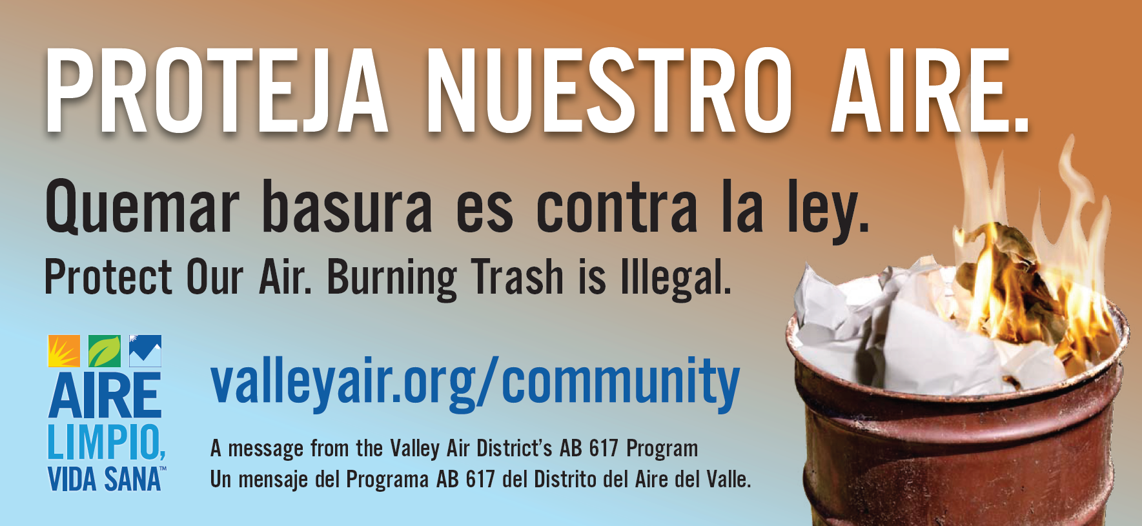

Enhanced Enforcement of Statewide Anti-Idling Regulation
To address the community concern of heavy-duty trucks and to limit the potential for localized PM2.5 and toxic air quality impacts associated with the failure to comply with the state’s heavy duty anti-idling idling regulation, District staff performed quarterly anti-idling surveillance. Locations where surveillance was conducted was based on CSC input provided to the District and CARB. To ensure District staff are focusing in the areas where residents are being impacted , the District has included agenda discussions in CSC meetings to provide updates on these efforts and to receive CSC feedback on areas of focus on while doing surveillance and will continue to do so moving forward. District staff also spoke directly to businesses, who rely on heavy-duty trucking, identified by the CSC to provide compliance assistance and education regarding the state’s anti-idling Airborne Toxic Control Measure requirements and steps to be taken to ensure compliance. While there were no violations discovered during the surveillance performed, the District believes that the outreach provided to businesses in the community will contribute to increased compliance with the state’s requirements.

Enhanced Inspection Frequency of Stationary Sources
The District conducts inspections and investigations of permitted sources to determine compliance with a multitude of health-protective local, state, and federal air quality regulations targeting both criteria and toxic pollutants. These include (1) District rules and permit requirements; (2) statewide Airborne Toxic Control Measures; (3) statewide greenhouse gas regulations; and (4) federal New Source Performance Standards, National Emission Standards for Hazardous Air Pollutants, and Maximum Available Control Technology standards. The District closely monitors such sources and strictly enforces applicable requirements. Compliance inspections are unannounced whenever possible and involve both a physical inspection of the facility and a review of operating and monitoring records.

To address the primary community concerns of oil and gas operations and agricultural sources in addition to other permitted sources of air pollution, the District reviewed the enforcement history of all permitted facilities in the community, including those with an emissions violation within the last three years. The District committed to performing inspections of these facilities at least twice per calendar year for the next five years or until the facility has four consecutive inspections without an emission violation, whichever comes first. District staff has fully implemented this measure and continues to conduct inspections on an increased frequency each year.

Pilot Training Program for Conducting Self-Inspections at Gas Stations
To address the community concern of oil and gas operations, the District has drafted a training outline, however, due to the close one-on-one interaction that is needed to train gas station owners/operators on conducting hands-on vapor recovery system inspections, training will be postponed until COVID-related restrictions are lifted.

- Metrics for Tracking Progress.
The District and CSC included a robust set of metrics to track progress in the Shafter CERP. To the maximum extent possible, the District has looked to tie emissions reductions targets to individual CERP measures. Of the 54 measures in the adopted CERP, 25 are incentive-based measures where the District and CSC worked to identify the number of units targeted for replacement, by year, throughout implementation of the CERP. The remaining measures, whether incentive-based, enforcement, outreach, mitigation, or a land use partnership, have metrics that outline the expected emissions reductions, number of planned inspection hours, scheduled meetings, or other interactions expected for the implementation of the each measure. The District continues to reassess and evaluate these metrics with the CSC as CERP implementation meetings continue. As CARB approves the District’s project plans and incentive based measure spending increases, the District will keep the CSC apprised at subscription rates for the various measures and will solicit feedback on whether funding amounts need adjusting.

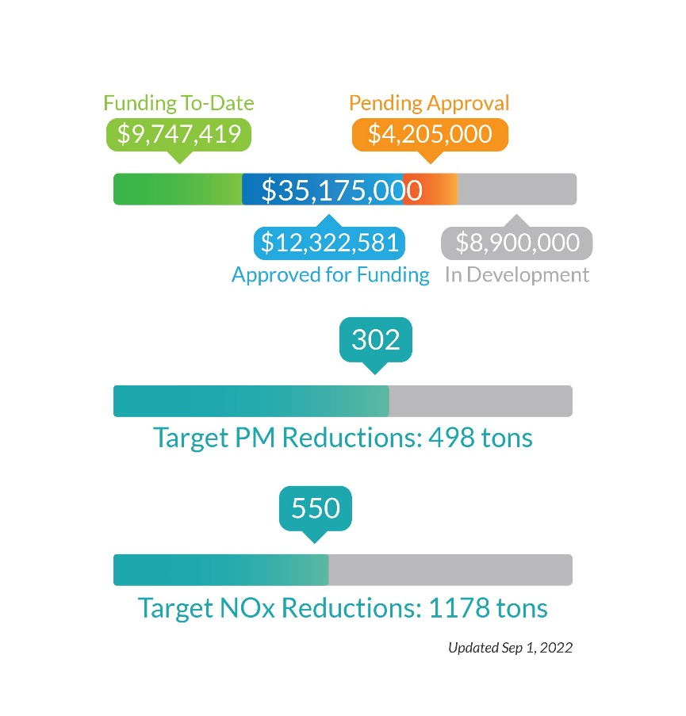
The CSC has made it clear that having the ability to track and measure implementation progress in English and Spanish is very important. Towards that end, the District developed a measure tracker that is updated on a monthly basis in both English and Spanish on the top of the Shafter AB 617 Community Webpage under the heading “Track Shafter Progress.” District staff have taken the opportunity to share the tracker with the community on multiple occasions and have taken and incorporated feedback from CSC members.

Shafter CERP Measures Tracker:

English: http://community.valleyair.org/shafter-tracker/
Spanish: http://community.valleyair.org/shafter-tracker-sp/

- Implementation Schedule.
The approved CERP includes numerous incentive-based measures identified and prioritized by the CSC. These measures include a variety of projects and programs that are already approved for funding through CARB’s Community Air Protection (CAP) Guidelines, including electric school bus replacement, school filtration, truck and off-road equipment replacement and alternative fuel infrastructure.

The approved CERP includes numerous incentive-based measures identified and prioritized by the CSC. These measures include a variety of projects and programs that are already approved for funding through CARB’s Community Air Protection (CAP) Guidelines, including electric school bus replacement, school filtration, truck and off-road equipment replacement and alternative fuel infrastructure.

The District had been working closely with the CSC on prioritizing and implementing these measures as feasible throughout the community. The CERP also includes numerous measures that fall outside of the pre-approved program categories included in the CAP Guidelines. However, the CAP Guidelines include a process to develop project plans for these new and innovative CERP incentive measures for funding utilizing available funding.

Project Plans
For all incentive-based measures that require project plans under the CAP guidelines, the District has been working to draft and submit plans to CARB for review and approval. As project plans are pending and approved, the District has worked with the CSC to solicit outreach and implementation feedback for each measures. The figure below describes the status of the various CARB-required project plans as of September 15, 2021. For an updated list and to view project plans and CARB approval letters, visit the link below:
Project Plans: http://community.valleyair.org/grants-and-incentives

- Data Analysis.
The District worked with the Shafter CSC to develop and deploy a community air monitoring plan consists capable of proving real-time air quality information to the community.

Throughout the past year, the District continued to engage the Shafter CSC on planning and deploying the CSC-designed Community Air Monitoring Plan. As monitoring capabilities continue to be deployed in the community, the District regularly provides updates to the Shafter CSC regarding air quality data analysis and solicits further recommendations for new monitoring sites if deployment issues arise. Consistent with the community recommended CAMP design, air monitoring systems have been fully implemented in almost all locations.

Community Air Monitoring to Date
The District has invested an extensive amount of work into implementing the community air monitoring plan as expeditiously as possible, including researching, developing, configuring, deploying, trouble-shooting, and maintaining new state-of-the-art high precision air monitoring equipment. Real-time information, including the interactive map in the figure below, can be found at: http://community.valleyair.org/selected-communities/shafter/community-air-monitoring/

Special Project and Analysis
In addition to the stationary sites described above, the District’s monitoring team has responded to community concerns using a mobile air monitoring capabilities, allowing staff to deploy criteria and toxics air monitoring technologies to currently unmonitored areas within the region. More recently, the mobile monitoring van has been used to supplement the needs of the La Colonia Mexicana community while staff work with property owners to site a stationary site.

To help analyze both mobile and stationary monitoring of certain air pollutants and air toxics, the District has also contracted with analytical laboratories to conduct the needed analysis to speciate the VOC and PM2.5 samples being taken in the community. In addition, the District has worked closely with organizations to negotiate leases to authorize the deployment of the equipment on site, followed by logistical, electrical, and site preparation work for the installation of the air monitoring equipment.

- Strategy Development.
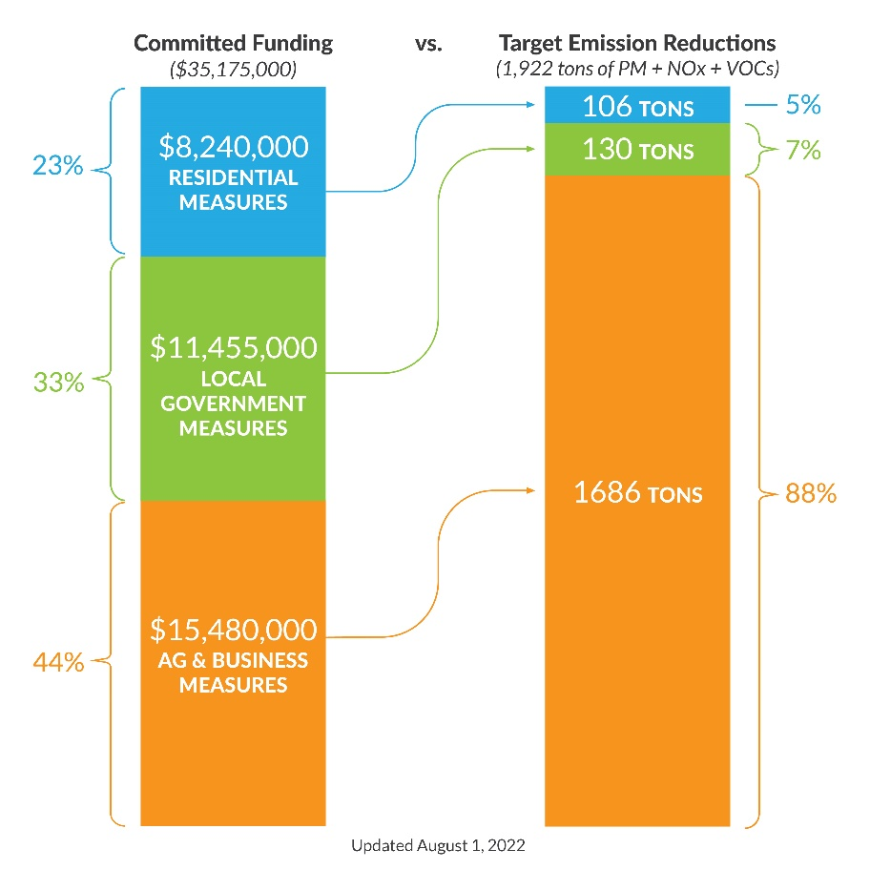
The District and CSC included a robust set of metrics to track progress in the Shafter CERP. To the maximum extent possible, the District has looked to tie emissions reductions targets to individual CERP measures. Of the 54 measures in the adopted CERP, 25 are incentive-based measures where the District and CSC worked to identify the number of units targeted for replacement, by year, throughout implementation of the CERP. The remaining measures, whether incentive-based, enforcement, outreach, mitigation, or a land use partnership, have metrics that outline the expected emissions reductions, number of planned inspection hours, scheduled meetings, or other interactions expected for the implementation of the each measure. The District continues to reassess and evaluate these metrics with the CSC as CERP implementation meetings continue. As CARB approves the District’s project plans and incentive based measure spending increases, the District will keep the CSC apprised at subscription rates for the various measures and will solicit feedback on whether funding amounts need adjusting.

Community Input on Incentives Program Funding Changes

For all incentive-based measures, the District has closely monitored program demand and kept the CSC members apprised. In some cases, we have found measures that are no longer feasible as originally aspired to in CERP development.

Throughout 2022, the District has worked closely with CARB and the CSC to assess interest and support for reallocating funding, as described below.

CERP Measure | Status | Original Funding | Updated Funding
Locomotive Switchers | Few interested project partners, moved some funding to other measures | $4.1M | $2M
School Air Filtration | No interested project partners, moved all funding to NEW CERP measure for residential air filtration | $250K | $0
Residential Air Filtration | CSC interested in support residents, as well as daycare and adult care facilities | Not in CERP | $1M
Vegetative Barriers | CSC interested in funding the previously unfunded measure to increase interest in program | $0 | $1M
Fireplace Replacement | CSC interested in increasing incentive to cover total cost of replacement (from $3K to $4.1K) | $600K | $800K

The District will continue to work closely with the CSC throughout this process to prioritize funding in areas and programs of specific interest to the CSC and incorporate new program ideas based on CSC member feedback and as feasible.

- Highlight any “lessons learned” that can be used to support communities with similar sources and air quality challenges. [Ref. Blueprint, page C-39]

New Facilitator Selection
In May 2021, the Institute for Local Government (ILG), the facilitation team that had been providing services to the Shafter CSC meetings since 2019, indicated that they no longer had the capacity to facilitate all four AB 617 communities across the Valley. At the same time, CSC members expressed an interest in having an open, transparent, and inclusive participatory process to consider and provide recommendations on the next facilitator for their community.
The District opened up a Request for Quotation (RFQ) in June 2021, soliciting a facilitation team capable of meeting the high standards of creating an inclusive and open environment for community engagement efforts as part of the District’s AB 617 efforts in Shafter. The District received RFQs from two facilitation teams, both at the recommendation of CSC members, with demonstrated experience and expertise in this area.

All CSC members were then invited to participate in a process to interview the potential new facilitators by submitting questions to ask the interested parties and to hear their responses during and evening webinar. Prior to the webinar, all CSC members were sent a summary of the RFQ respondent’s qualifications and experience. Numerous CSC members from each Valley AB 617 community submitted questions, which the District forwarded to the applicants and were read aloud during the webinar for transparency. The 2-hour webinar was held on the evening of Thursday, August 19. Real-time interpretation was provided, in both Spanish and American Sign Language, and the webinar was recorded and a link posted on the AB 617 website and an email shared with all CSC members, providing a link to the webinar. The District requested that each CSC member who had the opportunity to watch the webinar to provide their recommendation on the facilitation provider they believed would best serve the needs of their CSC.

Based on CSC feedback and recommendations, Harder + Company was selected as the next facilitation team for AB 617 community steering committee meetings moving forward.

- The community emissions reduction program will have included a community profile. Describe any community profile updates, such as the following information, if applicable: [Ref. Blueprint, page C-39]
3a) Describe changes in community attributes (e.g., revised socioeconomic data).
As discussed in CARB’s Blueprint, a core focus on achieving emissions reductions and tracking ongoing progress is needed to address public health risks that may be caused by air pollution exposure. Consideration of public health includes taking health risks into account in identifying and selecting emissions reduction strategies, evaluating health risks in the context of newly acquired air monitoring information, as well as exploring ways to better understand data on community health and its potential relationship to past or ongoing pollutant exposure. In the Blueprint CARB recognizes that individual and community health is influenced by many factors including exposure to other environmental hazards (e.g., drinking water contaminants, tobacco smoke), individual level vulnerability (e.g., diet, genetic factors), as well as structural determinants of health such as neighborhood poverty, racial/ethnic segregation, violence, access to food and health care, and lack of green space.

Towards this end, the District has gathered some baseline data in the Shafter AB 617 Community in Appendix G of the CERP and will continue to work with the Steering Committee, OEHHA, CARB, and health researchers to track and support local research efforts to understand the public health impacts of local and regional emissions reduction efforts.

3b) List any new community attributes that have been identified (e.g., new local public health indicators).
No additional community attributes have been identified since the District adoption of the CERP.
- In its oversight role, the CARB Governing Board may identify interim implementation milestones, either during its initial consideration of the community emissions reduction program for approval, or as discussed in any subsequent CARB Governing Board meetings. Provided below are action items specified during CARB’s Board Meeting in February 2020. [Ref. Blueprint, page C-40]
Please use the form below or provide an attachment that describes updates and progress towards the following interim implementation milestones:
Action Items in CARB Board Resolution 20-6 and CARB Staff Report
CARB staff works with the District, DPR, and the community steering committee to take the additional actions to strengthen implementation, as defined in the Staff Report on pages 8 and 9 and as modified by this Resolution, to do the following:
- Board-Directed Action #1: Include a process for making adjustments to incentive measure funding amounts based on ongoing discussions and recommendations from the community steering committee, and continue engaging the committee on prioritization of incentive measures and project selection.

Community Input on Incentives Program Funding Changes

For all incentive-based measures, the District has closely monitored program demand and kept the CSC members apprised. In some cases, we have found measures that are no longer feasible as originally aspired to in CERP development.

Throughout 2022, the District has worked closely with CARB and the CSC to assess interest and support for reallocating funding, as described below.

CERP Measure | Status | Original Funding | Updated Funding
Locomotive Switchers | Few interested project partners, moved some funding to other measures | $4.1M | $2M
School Air Filtration | No interested project partners, moved all funding to NEW CERP measure for residential air filtration | $250K | $0
Residential Air Filtration | CSC interested in support residents, as well as daycare and adult care facilities | Not in CERP | $1M
Vegetative Barriers | CSC interested in funding the previously unfunded measure to increase interest in program | $0 | $1M
Fireplace Replacement | CSC interested in increasing incentive to cover total cost of replacement (from $3K to $4.1K) | $600K | $800K

The District will continue to work closely with the CSC throughout this process to prioritize funding in areas and programs of specific interest to the CSC and incorporate new program ideas based on CSC member feedback and as feasible.

- Board-Directed Action #2: Develop and provide specific criteria for project funding amounts and project selection, and clarify in the “Metrics to Track Progress” the process for adjusting allocations when projects are undersubscribed or oversubscribed, including the following considerations:
- Provide funding for the replacement of natural gas residential heating devices with electrical heat pumps without requirements for the replacement of a fireplace or wood burning device.
- Provide sufficient flexibility to ensure the passenger vehicle replacement strategy can be fully subscribed.
- Provide mechanisms and resources for the ongoing maintenance of trees as part of the urban greening strategy.

Emissions Reduction Targets and Metrics for Tracking Progress

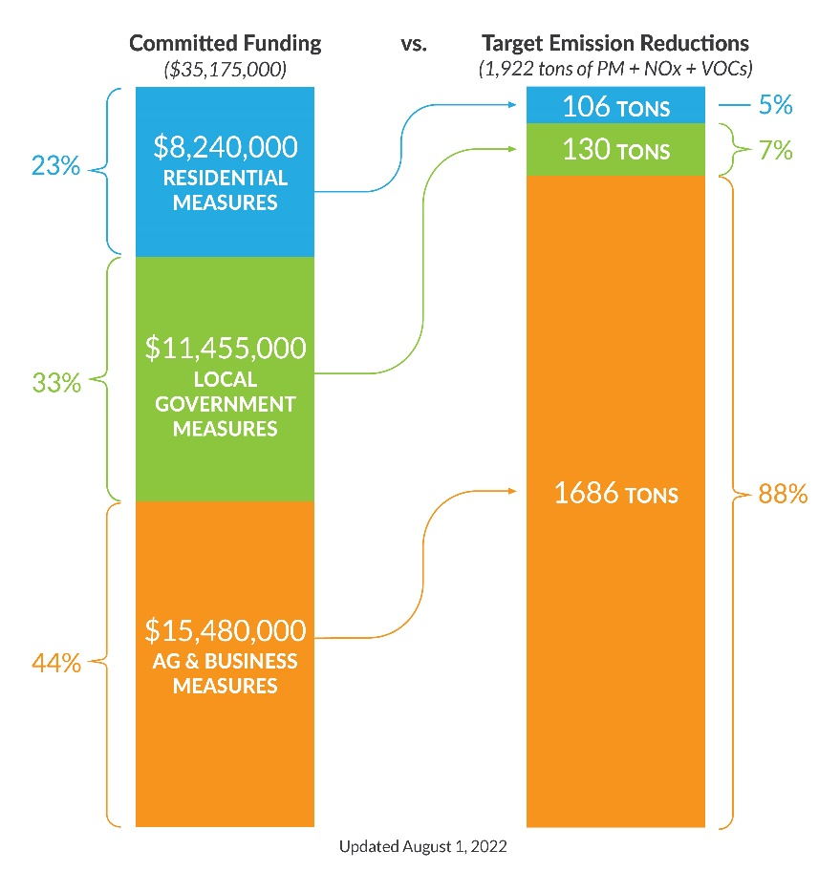
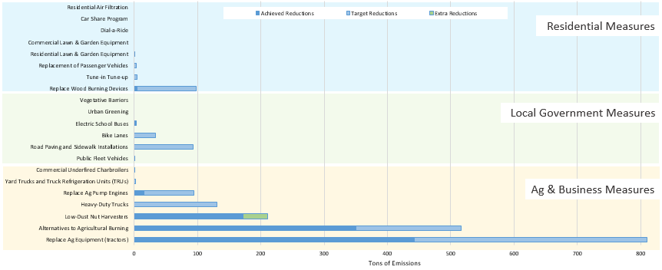
The District and CSC included a robust set of metrics to track progress in the Shafter CERP. To the maximum extent possible, the District has looked to tie emissions reductions targets to individual CERP measures. Of the 54 measures in the adopted CERP, 25 are incentive-based measures where the District and CSC worked to identify the number of units targeted for replacement, by year, throughout implementation of the CERP. The remaining measures, whether incentive-based, enforcement, outreach, mitigation, or a land use partnership, have metrics that outline the expected emissions reductions, number of planned inspection hours, scheduled meetings, or other interactions expected for the implementation of the each measure.
The District continues to reassess and evaluate these metrics with the CSC as CERP implementation meetings continue. As CARB approves the District’s project plans and incentive based measure spending increases, the District will keep the CSC apprised at subscription rates for the various measures and will solicit feedback on whether funding amounts need adjusting.

The CSC has made it clear that having the ability to track and measure implementation progress in English and Spanish is very important. Towards that end, the District developed a measure tracker that is updated on a monthly basis in both English and Spanish on the top of the Shafter AB 617 Community Webpage under the heading “Track Shafter Progress.” District staff have taken the opportunity to share the tracker with the community on multiple occasions and have taken and incorporated feedback from CSC members.
Shafter CERP Measures Tracker:

English: http://community.valleyair.org/shafter-tracker/
Spanish: http://community.valleyair.org/shafter-tracker-sp/

- Board-Directed Action #3: Update the emissions reduction targets as new information becomes available for the regulatory and other strategies that do not yet have defined benefits where quantification is feasible.
The District will update the emissions reduction targets as new information becomes available for the regulatory and other strategies that do not yet have defined benefits where quantification is feasible.
- Board-Directed Action #4: Consider the specific impacts of exposure to 1,3-D in the Shafter community to inform development of DPR’s statewide rulemaking for 1,3-D; and
The District has facilitated conversations with DPR, CARB, and the CSC to discuss the work that DPR is doing to limit resident exposure to 1,3-D pesticides, including pilot mitigation project that is beginning in the Shafter area. The District has requested and DPR has provided monthly updates to the steering committee on this topic. Since May 2020, DPR staff have attended every CSC meeting and have a standing item on the agenda to address and update the community on the CERP measures addressing pesticides.

- Board-Directed Action #5: Continue to work together to identify additional actions related to the pesticide concerns identified by community steering committee members.
The District has facilitated conversations with DPR, CARB, and CSC members to discuss the work that DPR is doing to address the community’s concerns regarding pesticide usage and DPR continues to attend and participate in monthly meetings with the CSC to obtain additional feedback and answer questions.

As of September 2022, the Shafter CSC will be invited to participate in ongoing pesticide subcommittee meetings with the Arvin/Lamont CSC, District, CARB, DPR, OEHHA, and the Kern County Agricultural Commissioner. These discussions will include updates on statewide rulemaking efforts, including 1,3-D mitigation, application notification, and sustainable pest management.

- Board-Directed Action #6: Continue to collect and develop additional Shafter specific emissions information to build upon the current community-level inventory.
A community webpage has been created for the Shafter AB 617 community, and is regularly updated with new information (http://community.valleyair.org/selectedcommunities/shafter). The webpage includes information about upcoming meetings, meeting materials (flyers, agendas, presentations, handouts, audio and video links, meeting summaries), interactive maps, community steering committee roster and committee charter, membership process, and the Community Air Monitoring Plan (CAMP) and CERP documents.

- Board-Directed Action #7: DPR works to implement a pilot study for 1,3-D in Shafter and include mitigation methods that achieve reductions equivalent to Totally Impermeable Film (TIF) tarping.
The District has facilitated conversations with DPR and CARB with the CSC to discuss the work that DPR is doing to limit resident exposure to 1,3-D pesticides, including the pilot mitigation project that is beginning in the Shafter area. The District has requested and DPR has provided monthly updates to the steering committee on this topic.

As of September 2022, the Shafter CSC will be invited to participate in ongoing pesticide subcommittee meetings with the Arvin/Lamont CSC, District, CARB, DPR, OEHHA, and the Kern County Agricultural Commissioner. These discussions will include updates on statewide rulemaking efforts, including 1,3-D mitigation, application notification, and sustainable pest management.

- Board-Directed Action #8: At CARB’s request and review, the District updates the Program’s technical description of regulatory authorities over pesticides and requirements for pesticide notifications to be consistent with the State’s language contained in the Staff Report and this Resolution under the administrative delegation provided to the Air Pollution Control Officer.
The District has been working closely with the Department of Pesticide Regulation (DPR) as the agency with authority over pesticide application to assist in the development of pesticide mitigation and pesticide use notification and making sure that the CSC is provided regular updates on the work being done at each of the CSC meetings. In addition to working with DPR to gather relevant air monitoring data and other beneficial information and making it available on the Shafter AB 617 community webpage.

As of September 2022, the Shafter CSC will be invited to participate in ongoing pesticide subcommittee meetings with the Arvin/Lamont CSC, District, CARB, DPR, OEHHA, and the Kern County Agricultural Commissioner. These discussions will include updates on statewide rulemaking efforts, including 1,3-D mitigation, application notification, and sustainable pest management.

- Board-Directed Action #9: CARB staff, the District, DPR, and the community steering committee report back to the Board semi-annually, or as directed by the Board, on implementation of these actions.
The District has provided the CSC and CARB a monthly update on CERP implementation progress, weekly updates on air monitoring progress, quarterly in-depth reports on air monitoring and enforcement actions, and an annual report of CERP and Enforcement plan implementation.

All of these are translated into Spanish and sent to residents before taking to CARB.
Furthermore, the District has been working closely with the Department of Pesticide Regulation (DPR) as the agency with authority over pesticide application to assist in the development of pesticide mitigation and pesticide use notification and making sure that the CSC is provided regular updates on the work being done at each of the CSC meetings. In addition to working with DPR to gather relevant air monitoring data and other beneficial information and making it available on the Shafter AB 617 community webpage.

As of September 2022, the Shafter CSC will be invited to participate in ongoing pesticide subcommittee meetings with the Arvin/Lamont CSC, District, CARB, DPR, OEHHA, and the Kern County Agricultural Commissioner. These discussions will include updates on statewide rulemaking efforts, including 1,3-D mitigation, application notification, and sustainable pest management.

- Summarize the status of rules and regulations adopted that impact the community. [Ref. Shafter Program, Section 6.1, page 179]

PM2.5 Plan Rule Updates
District staff have continued moving forward with technical evaluation and public engagement efforts for scheduled regulatory measures, with several District rules scheduled for proposed amendments in the 2021-22 timeframe. Emissions reductions achieved through the implementation of more stringent limits potentially required through these rule amendments will further contribute to reduced exposure to air pollution in the community. CSC members, members of the AB 617-selected community, and the public are encouraged to be involved in the upcoming rulemaking process for these rules.

Rule | Stationary/Area Source Category | Rule Development Status
4901 | Wood burning fireplaces and heaters | Rule Amended June 20, 2019
4311 | Flares | Rules amended December 17, 2020
4306 & 4320 | Boilers, steam generators, and process heaters
4702 | Internal combustion engines | Rule amended August 19, 2021
4692 | Under-fired charbroilers at commercial restaurants | Rule amendment evaluation ongoing
4354 | Glass Melting Furnaces | Rule amended December 16, 2021
4352 | Solid-Fuel Fired Boilers | Rule amended December 16, 2021

Best Available Retrofit Control Technology (BARCT)
AB 617 required districts that are in nonattainment for one or more air pollutants to adopt expedited schedules by January 2019 for the implementation of Best Available Retrofit Control Technology (BARCT). Significant work was necessary to demonstrate that existing rules met BARCT requirements or, where it was not clear that BARCT requirements were met, identify potential gaps in the existing rules, establish a rule-review schedule, and take the schedule to the District’s Governing Board for approval before the deadline. The Board adopted the District’s BARCT Analysis Schedule on December 20, 2018. The District is now implementing the plan, and, where necessary, develop rule amendments consistent with state BARCT requirements. The District must also share its findings with the state as CARB compiles the BARCT clearinghouse.

District’s expedited BARCT Schedule: http://community.valleyair.org/best-available-retrofit-control-technology-barct

Since 2019, the District has performed a further BARCT analysis of 13 of the 16 rules identified, typically in the order of documented priority. Each District rule and source category are evaluated in comparison to federal and state air quality regulations, and the regulations of other air districts in California and throughout the country.
The District held a public workshop on April 20, 2021 and provided a update to the public on the progress the District has made on the BARCT evaluations for 4 rules conducted in 2020 (see published report – link) and discussed the next steps associated with further evaluating the remaining District Rules for satisfying BARCT requirements. The following table summarizes the status of the BARCT rule evaluations.

Rule | Title | BARCT Status
4454 | Refinery Process Unit Turnaround | Meets BARCT
4641 | Cutback, Slow Cure, And Emulsified Asphalt, Paving And Maintenance Operations | Meets BARCT
4104 | Reduction of Animal Matter | Meets BARCT
4409 | Components at Light Crude Oil Production Facilities, Natural Gas Production Facilities, and Natural Gas Processing Facilities | Combined rule development public process to evaluate/implement additional BARCT requirements in progress - expediting the rulemaking efforts for three of the five rules (Rules 4623, 4624, and 4401) to streamline assessment.  Rule Amendment scheduled 2022
4455 | Components at Petroleum Refineries, Gas Liquids Processing Facilities, and Chemical Plants
4623 | Storage of Organic Liquids
4624 | Transfer of Organic Liquids
4401 | Steam-Enhanced Crude Oil Production Wells
4702 | Internal Combustion Engines (VOC only) | Rule amended August 19, 2021
4694 | Wine Fermentation and Storage Tanks | Removed from Expedited BARCT Schedule
4603 | Surface Coating of Metal Parts and Products, Plastic Parts and Products, and Pleasure Crafts | Meets BARCT
4601 | Architectural Coatings | BARCT Rule Adopted 4/16/20
4566 | Organic Material Composting Operations | Removed from Expedited BARCT Schedule
4625 | Wastewater Separators | BARCT evaluation scheduled for 2021 completion
4621 | Gasoline Transfer Into Stationary Storage Containers, Delivery Vessels, and Bulk Plant | BARCT evaluation scheduled for 2021 completion
4402 | Crude Oil Production Sumps | BARCT evaluation scheduled for 2021 completion
The District is also working with the affected facilities to identify the potential control options that may result in additional emissions reductions. The affected facilities are providing the District with technical information and costs related to potential control options to determine the feasibility of implementing each option identified.

- Summarize the interactions with other agencies to address local exposure to air pollution (e.g., number of meetings with city and county governments). [Ref. Shafter Program, Section 6.1, page 179]
In addition to the several example listed above in the District’s coordination with DPR, Kern County Ag Commissioner, OEHHA, and CARB, the District has regular meetings with the City of Shafter, Kern County, state, Richland Unified School District, other area Schools, CPUC, GRID Alternatives, and community organizations regarding the implementation of CERP measures. The District has also brought many of the organizations to speak at the CSC meetings to provide updates and to solicit feedback and to answer questions.
- Co-Benefits – Summarize additional co-benefits, including the following: [Ref. Shafter Program, Section 6.1, page 179]
- Trainings and Outreach, including number of public meetings held in the community and the number of people in attendance.
There have been over 60 meetings with the community over the past year, including webinars, in-person outreach events, CSC meetings, agenda setting meetings, subcommittee meetings, training calls with the facilitation team, and various other planning calls with community members

- Workforce Development.
The CERP contains workforce development that involves incentive funding. The District is currently developing the program plan for this measure and once approved, will work closely with the CSC to make the community aware of opportunities.
- Technical Capacity-Building.
Much of the work done during the CERP development process revolved around the technical capacity building of the CSC members. Considerable time was spent explaining what air pollution is, where it comes from, how it is monitored for, and options for reducing emissions and exposure. As a result of the CSC members commitment to the process, they have gained tremendous knowledge that they have in-turn shared with other members of the Shafter community.

Section A: QUANTITATIVE Summary of progress for the community emissions reduction program
- Status of the Strategies Included in the Program – Summarize the total number of strategies that have been fully implemented, the number that are in progress, and the number that have not yet begun implementation.
[Ref. Blueprint pages C-38, C-39. Shafter Program, Section 4, pages 43-152]
See data collection tracking spreadsheet.
- Completion of Required Elements – Describe completion of required elements (e.g., emissions reduction targets, milestones for compliance goals, etc.). Some required elements are provided below in 9a, 9b, and 9c.
[Ref. Blueprint pages C-3, C-4, C-38, C-40.
9a) Emission Reduction Targets – Summarize progress toward achieving overall emission reduction targets (PM2.5, PM10, DPM, NOX, and VOC, as applicable). [Ref. Blueprint pages C-16 to C-19, C-38, C-40. Shafter Program, pages 153-155]
See data collection tracking spreadsheet.
9b) Proximity-Based Goals - Summarize progress toward achieving proximity-based goals (e.g., for Health Air Living/HAL schools program, air filtration, vegetative barriers). [Ref. Blueprint pages C-19, C-20. Shafter Program, Section 6.1, page 179]
See data collection tracking spreadsheet.
9c) Compliance Goals - Provide an update on progress toward achieving compliance goals and improving compliance (e.g., summarize non-compliance rates and other key compliance statistics). [Ref. Blueprint page C-31. Shafter Program, Section 6.1., page 179]
See data collection tracking spreadsheet.
- Incentives Investments - Summarize the total investments for incentive programs deployed in and around the community that are identified in the community and the associated emissions reductions. [Ref. Shafter Program, Section 6.1, page 179]
See data collection tracking spreadsheet.
- Air Monitoring Results – For the five-year milestone report, summarize air monitoring results. [Ref. Shafter Program, Section 6.2, page 180, “…the five year milestone report submitted to CARB for Shafter will include a comprehensive report of air quality monitoring data obtained in the community throughout the term of the CERP…”]
See real-time, weekly, quarterly, and annual air monitoring progress here: https://community.valleyair.org/selected-communities/shafter/community-air-monitoring/

Report Section B: Status update for EACH STRATEGY in the community emissions reduction program
Please fill in the attached spreadsheet template and provide an update on the status and specific metrics for EACH STRATEGY. [Ref. Blueprint, page C-39]
[Use the attached spreadsheet to provide updates on each strategy]

[ATTACH SPREADSHEET FOR Report Section B: Status update for EACH STRATEGY in the community emissions reduction program]

Assembly Bill 617, Garcia, C., Chapter 136, Statutes of 2017; codified in California Health and Safety Code section 44391.2(c)(7) which states that each district “…shall prepare an annual report summarizing the results and actions taken to further reduce emissions, pursuant to the community emissions reduction program…”
California Air Resources Board, “Community Air Protection Blueprint”, October 2018, Appendix C, pages C-38 to C-40, available at: https://ww2.arb.ca.gov/our-work/programs/community-air-protection-program/community-air-protection-blueprint
San Joaquin Valley Air Pollution Control District, “Community Emissions Reduction Program Shafter” (i.e., Shafter Program), September 19, 2019, available at: http://community.valleyair.org/selected-communities/shafter.
CARB Board Resolution 20-6, dated February 13, 2020, available at: https://ww2.arb.ca.gov/board-resolutions-2020 and CARB document “Shafter, Community Emissions Reduction Program Staff Report” released January 24, 2020, available at: https://ww2.arb.ca.gov/resources/documents/shafter-community-emissions-reduction-program-staff-report.

